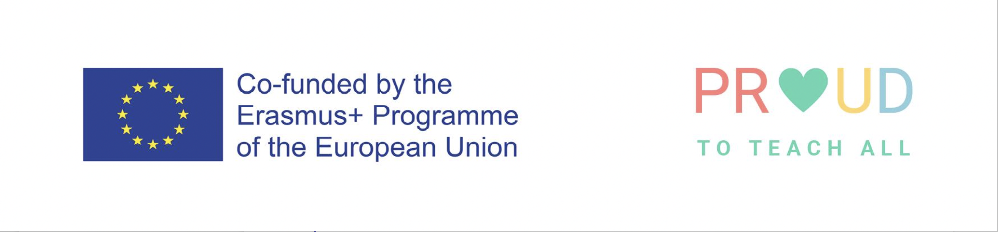

Lesson/Learning Study
Participant’s Information and Consent Form

Name:

I consent to participation in the Lesson/Learning Study | YES/NO* delete as appropriate
I consent to an anonymised ‘Case Story’ being developed with the researcher, based on the Lesson/Learning Study. | YES/NO
I consent to an anonymised ‘Case Story’ being shared at conferences and events, which disseminate the research | YES/NO
I consent to details from the Lesson Study (anonymised) being appropriately shared on social media | YES/NO
I consent to details from the Lesson Study (anonymised) being referred to in the project blog | YES/NO
I consent to (anonymised) notes relating to the Lesson/Learning study to be safely stored for a maximum of 10 years, and possibly used in future research | YES/NO

Keeping in touch with the project

I would like to receive updates about the progress of the project | YES/NO* delete as appropriate
I can be contacted about the project using the following details

Signed --------------------------------------------------------------------------------

Date ------------------------------------------------------------------------------------

